**Chapter 1**

**INTRODUCTION**

* 1. **Company Profile**

EXTREMITYINDIA is a Pune based company established in 2011.We concentrate on JAVA based solutions. Beside our own software products we also provide professional custom solutions.

We are a small startup from Pune. We started up in November 2011 with the purpose of developing good software’s through better design and practices. We are highly skilled and adept at building social, scalable web applications from start to finish.

We are pretty adept at User experience design, front end and back end programming and deploying solutions. At EXTREMITYINDIA with Technical proficiency and expertise, we cohesively integrate graphic design with web page layout, with interactive programming, with database driven content, to plan, build and deploy e- business and to emerge as one of the top IT service provider. We at EXTREMITYINDIA believe in teamwork .With every new day the quest for acquiring new competencies continues. Forever searching, experimenting, innovating, learning, moving ahead with our sincere efforts and dedication, shaping the future, and challenging our competencies to create new opportunities, is a never-ending process in the company.

* 1. **Existing System**
* The existing system did not provide facilities to its members like sharing idea and knowledge.
* The communication between the members was limited.
* The existing system did not provide any security for the organizational activities.
* Event planning for the organization was very difficult.
* Making announcement such as competition, events etc was time consuming.
* Conducting various competitions, social activities and other events was not feasible.
* Record maintenance of all the above was done manually which was very difficult.
* The existing system doesn’t connect the worldwide organizational people and employees.
  1. **Need of proposed system**
* “FRIENDS WORLDS“ is provide the security to organizational information.
* Friends Worlds is use to share information in that organization.
* We deﬁne social network sites as web-based services that allow individuals to construct a public or semi-public proﬁle within a bounded system.
* Articulate a list of other users with whom they share a connection, and view and traverse their list of connections and those made by others within the system.
* A social networking service is an online service, platform, or site that focuses on facilitating the building of social networks or social relations among people who, for example, share interests, activities, backgrounds, or real-life connections.
* Most social network services are web-based and provide means

for users to interact over the Internet, such as chatting .

* Online community services are sometimes considered as a social network service, though in a broader sense, social network service usually means an individual-centered service.
* whereas online community services are group-centered. Social

networking sites allow users to share ideas, activities, events,

and interests within their individual networks.

* Social networking sites are not only for you to communicate or interact with other people globally but, this is also one effective way for business promotion.
* A lot of business minded people these days are now doing business online and use these social networking sites to respond to customer queries. It isn't just a social media site used to socialize with your friends but also, represents a huge pool of information from day to day living.
* These are lots of reasons to use the system for more reliability in work.
  1. **Scope of Work**
* This system provides users to register their various types of profile like social, personal, general, professional.
* This system provides users to send a scrap message, images, and data files to their friends. User can maintain the scrap book whatever scraps he has send to users.
* The system provides user to upload the photos so that user can maintain own album.
* This system provides user to join the communities according to their scenario.
* This system provides the user to maintain their friend list and user can update their friend list.
* This system provides user to send invitation to another friend and can add to their friend list for future.
  1. **Operating Environment**

**Development environment**

**Hardware Requirements :**

Processor : Pentium IV 1.8 GHz

Memory size : 1 GB RAM

Storage : 40 GB Hard Disk

**Software Requirements:**

Operating System : Windows XP and above

Front-End Tool : HTML, Jsp, jQuery, Ajax, JavaScript,

J2EE (Java, Struts 2.0, Hibernate 3.0)

.

Back-End Tool : Mysql 5.0

**Deployment Environment**

**Hardware Requirements:**

Processor : Pentium III 800 MHz

Memory size : 128 MB RAM

Storage : 20 GB Hard Disk

**Software Requirements:**

Operating System : Windows XP and above

Web Browser : Internet Explorer 6.0

* 1. **Description of Technology**

**Java:**

Initially the language was called as “oak” but it was renamed as “Java” in 1995. The primary motivation of this language was the need for a platform-independent (i.e., architecture neutral) language that could be used to create software to be embedded in various consumer electronic devices.

**Apache Tomcat Server:**

Apache Tomcat is an open source software implementation

of the Java Servlet and Java Server Pages technologies. The Java Servlet and Java Server Pages specifications are developed under the Java Community Process.

Apache Tomcat is developed in an open and participatory environment and released under the Apache License version 2. Apache Tomcat is intended to be a collaboration of the best-of-breed developers from around the world. We invite you to participate in this open development project.

**JQuery:**

JQuery is a fast, small, and feature-rich JavaScript library. It makes things like HTML document traversal and manipulation, event handling, animation, and Ajax much simpler with an easy-to-use API that works across a multitude of browsers.

The purpose of jQuery is to make it much easier to use JavaScript on your website.

JQuery takes a lot of common tasks that require many lines of JavaScript code to accomplish, and wraps them into methods that you can call with a single line of code.

JQuery also simplifies a lot of the complicated things from JavaScript, like AJAX **calls and DOM manipulation.**

**MySQL:**

MySQL is a popular choice of database for use in web applications, and is a central component of the widely used LAMP open source web application software stack (and other 'AMP' stacks). LAMP is an acronym for "Linux, Apache, **MySQL**, Perl/PHP/Python."

MySQL, the most popular Open Source SQL database management system, is developed, distributed, and supported by Oracle Corporation.

## J2EE:

The Java 2 Platform, Enterprise Edition (J2EE) defines the standard for developing multitier enterprise applications. The J2EE platform simplifies enterprise applications by basing them on standardize, modular components, by providing a complete set of services to those components, and by handling many details of application behavior automatically, without complex programming.

The J2EE platform takes advantage of many features of the Java 2 Platform, standard edition (J2EE), such as “Write Once Run Anywhere” portability, JDBC API for database access, CORBA technology for interaction with exiting enterprise resources, and a security model that protects data even in internet applications. Building on this base, Java 2Platform, Enterprise Edition adds full support for enterprise JavaBeans components, Java Servlets API, Java Server Pages and XML technology.

The J2EE standard includes complete specifications and compliance tests to ensure probability of applications across the wide range of existing enterprise system capable of supporting the J2EE platform.

## STRUTS 2.0:

The struts framework was initially created by Craig McClanahan and donated to Apache Foundation in May, 2000 and Struts 1.0 was released in June 2001. The current stable release of Struts is 2.3.3 in May 3, 2012.

The Struts 2 framework is used to develop MVC (Model View Controller) based web applications. Struts 2 are the combination of web work framework of open symphony and struts1. The Struts 2 provides supports to POJO based actions, Validation Support, AJAX Support, Integration support to various frameworks such as Hibernate, Spring, Tiles etc., and support to various result types such as Freemarker, Velocity, and JSP etc. Struts2 is based on the Web works framework of Open Symphony.

## Model 2 (MVC) Architecture:

Model 2 is based on the MVC (Model View Controller) design pattern. The MVC design pattern consists of three modules model, view and controller.

**Model** The model represents the state (data) and business logic of the application.

**View** The view module is responsible to display data i.e. it represents the presentation.

**Controller** The controller module acts as an interface between view and model. It intercepts all the requests i.e. receives input and commands to Model / View to change accordingly.

## Advantages of MVC Architecture:

* Navigation control is centralized now only controller contains the logic to determine the next page.
* Easy to maintain
* Easy to extend
* Easy to test
* Better separation of concerns

**MySQL Database**

MySQL is the world’s most used relational database management system (RDBMS) that runs as a server providing multi-user access to a number of databases.

MySQL is an open source Relational Database Management System and it is very fast reliable and flexible Database Management System.

The data in MySQL is stored in database objects called tables.

Short introduction to MySQL as one of the most popular Structured Query Language (SQL) for adding, accessing and managing content in a database.

MySQL is a database system used on the web. Basically, a MySQL database allows you to create a relational database structure on a web server.

Hibernate:

Hibernate is an [object-relational mapping](http://en.wikipedia.org/wiki/Object-relational_mapping) (ORM) library for the [Java](http://en.wikipedia.org/wiki/Java_%28programming_language%29) language, providing a [framework](http://en.wikipedia.org/wiki/Software_framework) for mapping an [object-oriented](http://en.wikipedia.org/wiki/Object-oriented_programming) [domain model](http://en.wikipedia.org/wiki/Domain_model) to a traditional [relational database](http://en.wikipedia.org/wiki/Relational_database).

Hibernate solves [object-relational impedance mismatch](http://en.wikipedia.org/wiki/Object-relational_impedance_mismatch) problems by replacing direct [persistence](http://en.wikipedia.org/wiki/Persistence_%28computer_science%29)-related database accesses with high-level object handling functions.

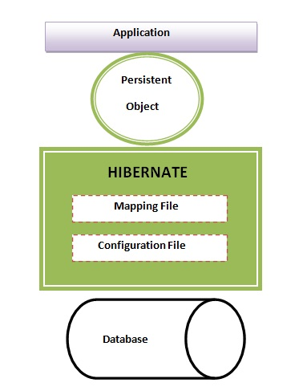

Hibernates primary feature is mapping from Java classes to database tables (and from Java data types to [SQL](http://en.wikipedia.org/wiki/SQL) data types). Hibernate also provides data query and retrieval facilities. Hibernate generates the SQL calls and attempts to relieve the developer from manual result set handling and object conversion and keep the application portable to all supported SQL databases with little performance overhead.

## JSP:

Java Server Pages (JSP) is a java technology that helps software developers serve dynamically generated web pages based on HTML, XML, or other document types.

JSP was designed to address the perception that the Java programming equivalent didn’t provide developers with enough support for the web.

JSP syntax is a fluid mix of two basic content forms: Scriptlet elements and markup. Markup is typically standard HTML or XML, while Scriptlet elements are delimited blocks of java code. When the page is requested the java code is executed and its output is added, in site, with the surrounding markup to create the final page.

JSP pages must be compiled to Java byte code classes before they can be executed, but such compilation is needed only when a change to the source JSP file has occurred.

The JSP syntax adds additional XML-like tags, called JSP actions, to invoke built in functionality.

**Chapter 2**

**PROPOSED SYSTEM**

* 1. **Proposed System**

A social networking site facilitate and develops a virtual community for people to share their thoughts, interest activities or to increase their horizon of camaraderie. With the advancement in Social networking sites or we can refer it as with online social networks the user can connect to each other.

With all these options available on Social Networking sites it creates a virtual world for the users. Social Networking sites go upwards because of all these reasons.

In recent years indicates that for many people they are now the mainstream communication technology. Social networking sites come under few of the most frequently browsed categories websites in the world.

Nevertheless Social Networking sites are also vulnerable to various problems threats and attacks such as disclosure of information, identity thefts etc. Privacy practices in social networking sites often appear convoluted as information sharing stands in discord with the need to reduce disclosure-related abuses.

Facebook is one such most popular and widely used Social Networking sites which has its own robust set of Privacy policies. Yet they are also

prone to various privacy issues and attacks. In this work we examine the currently existing privacy policies of Facebook since 2013 and then provide with certain new policies that enhance

and strengthen the existing ones.

We conclude with a discussion of how these educts may be integrated into the design of Facebook like Social Networking sites systems to facilitate

Interaction while enhancing the individual privacy.

* 1. **Objective Of the System**
* To carry out **nine ethnographic studies**, each of 15 months, in order to investigate how people actually use social media today.
* To explore the impact of social media on people’s relationships in that organization**.**
* To examine how social media has impacted upon key issues.
* To explore the way social media has been used within organization.
* To provide insights on what an in-depth ethnographic study of social media might bring to **social science** more generally.
* To consider the current state of the 'digital divide' and how social media relates to the problems of **low income populations** and their welfare.
  1. **User Requirements**

**Functional Requirement:**

* The system should have user friendly user interface.
* For adding/updating information link button should be there.
* It should take less time to perform action.
* Different user friendly icons are used to navigate from one page to another.

**Operational Requirement:**

* Proper validation checking at input time.
* Password is in encrypted format.
* For each role, the authentication (using Login ID and Password) is checked.
* Generate record according to the requirement.

**Performance Requirement:**

* The system should be such that it stores the user input in an efficient and secure way and make data available in a proper format on the screen.

**Design Constraints:**

* The design should be such that the UI supports the proposed hardware for the system.
* The user can navigate to the home screen from anywhere.
* Each screen should contain the link button to move anywhere.

**Acceptance Criteria:**

* Before accepting the system the developer must demonstrate the system work properly.
* The developer will have to show through test cases that all conditions are working.

**Chapter 3**

**ANALYSIS AND DESIGN**

**ER-Diagram**

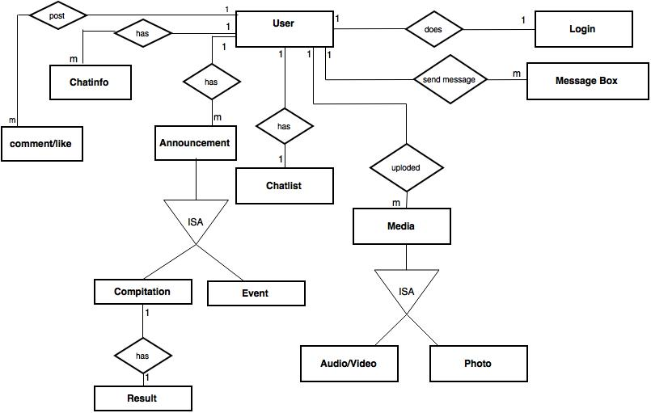

**Class Diagram**

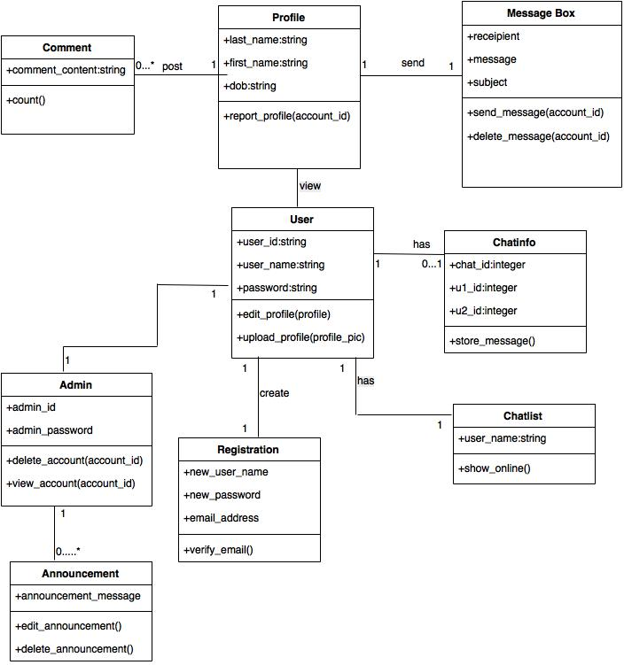

**Use Case Diagram**

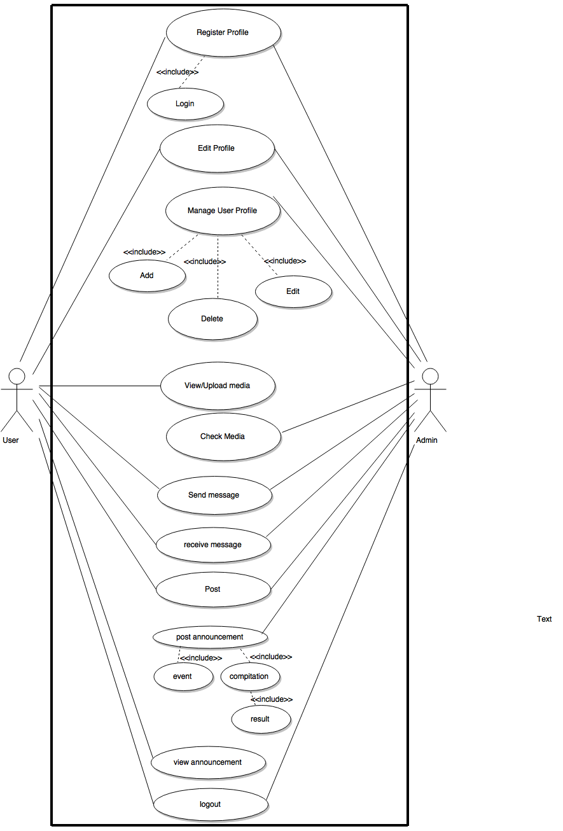

**Activity Diagram**

**Admin**

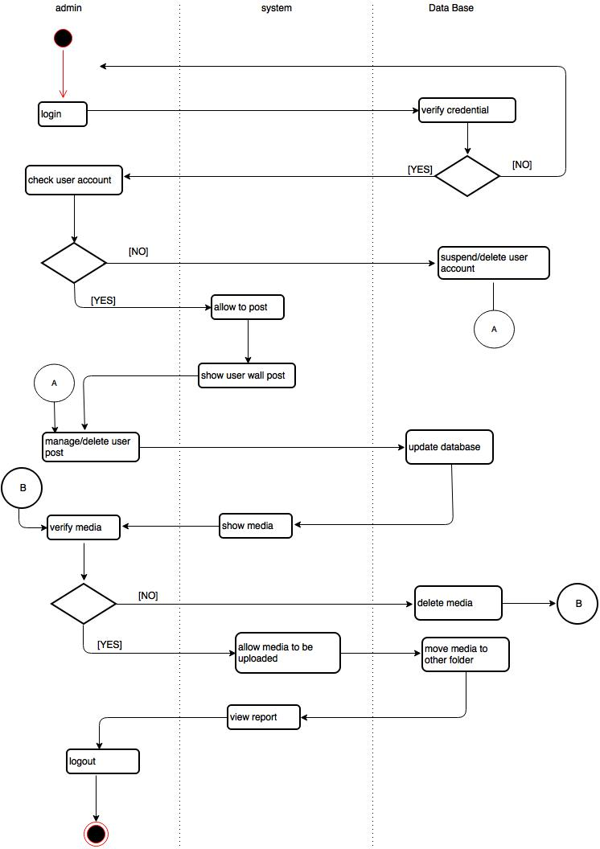

**Activity Diagram**

**User**

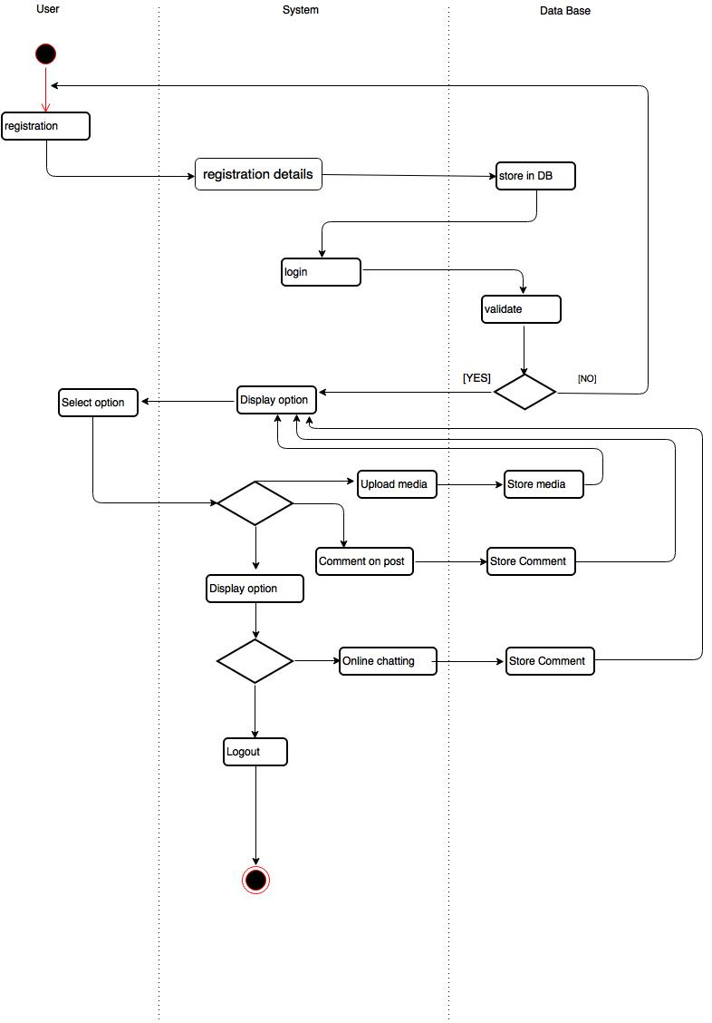

**Sequence Diagram**

**Admin**

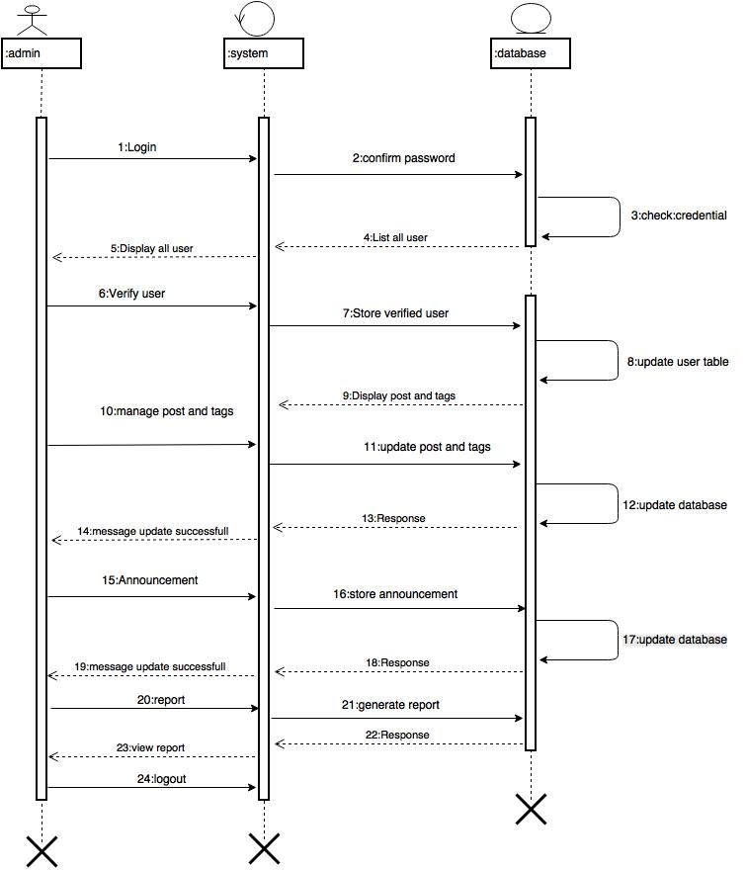

**Sequence Diagram**

**User**

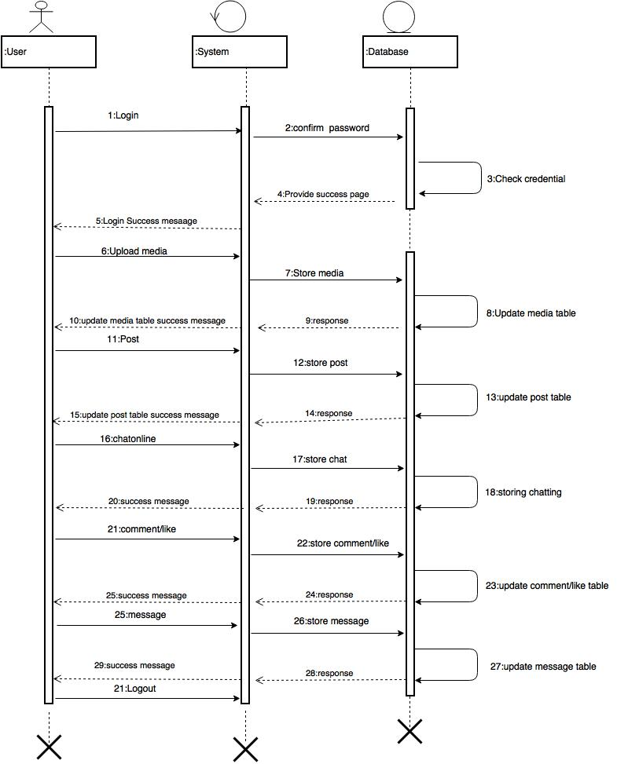

**Component Diagram**

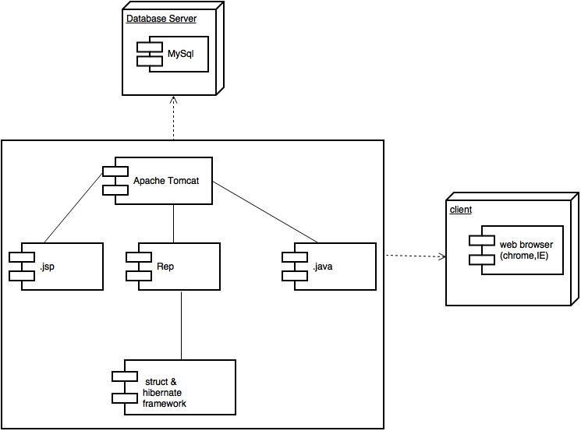

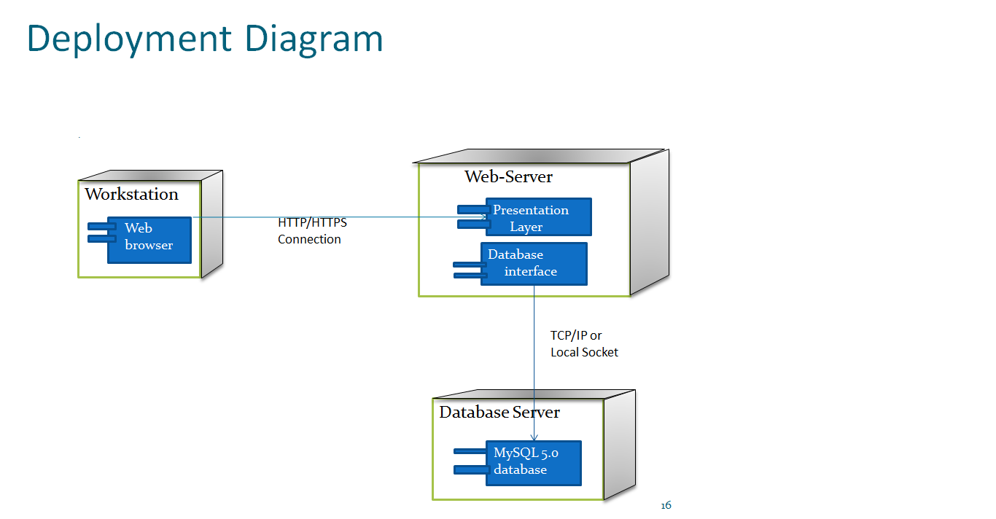

**Context Level Diagram**

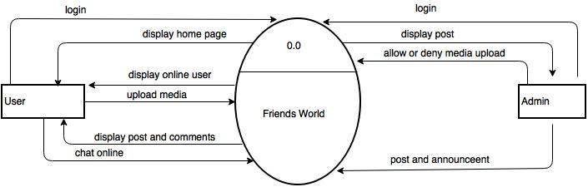

**Web Site Map**

**Admin**

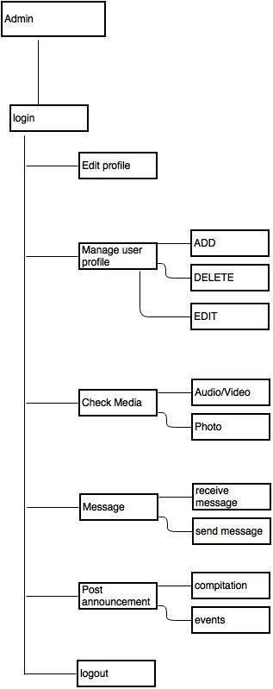

**Web Site Map**

**User**

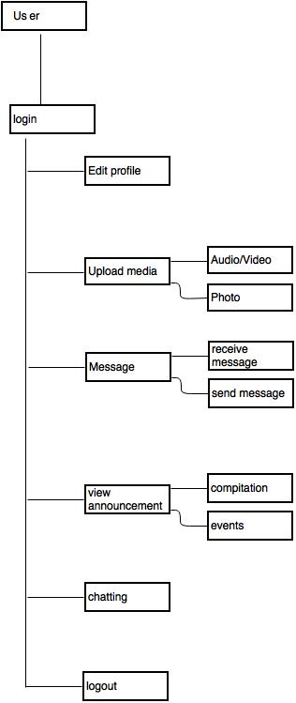

**Web Site Map**

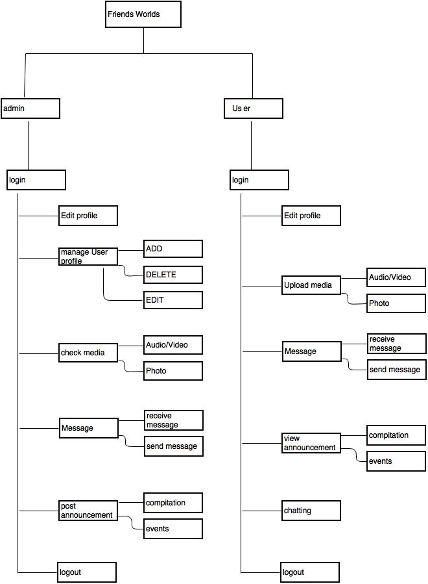

**Module specification**

**Chatting**

|  |  |
| --- | --- |
| Module Name | Chatting |
| Role | User |
| Short Description | User sends and receives messages to online user. |
| Screen s | 1) View online user screen  2) View chat screen |
| Output | Chatting is done. |

**Announcement**

|  |  |
| --- | --- |
| Module Name | Announcement |
| Role | User , Admin |
| Short Description | Admin post the announcement such as event or compitation etc. And user view the announcement. |
| Screens | 1. Post announcement screen 2. View announcement screen |
| Output | User know about the competition and events. |

**Message**

|  |  |
| --- | --- |
| Module Name | Message |
| Role | User, Admin |
| Short Description | Online user send messages to offline users and admin.  Admin send and receive the messages . |
| Screens | 1)view message screen |
| Output | User send message to offline user. |

**Upload Media**

|  |  |
| --- | --- |
| Module Name | Upload Media |
| Role | User , Admin |
| Short Description | User uploaded the media such as audio/video or photo etc.  Admin check the media means media content is valid or not. |
| Screen s | 1)uploaded media screen  2)view media screen  3)check media screen |
| Output | Upload and check the media. |

**Screen Shots**

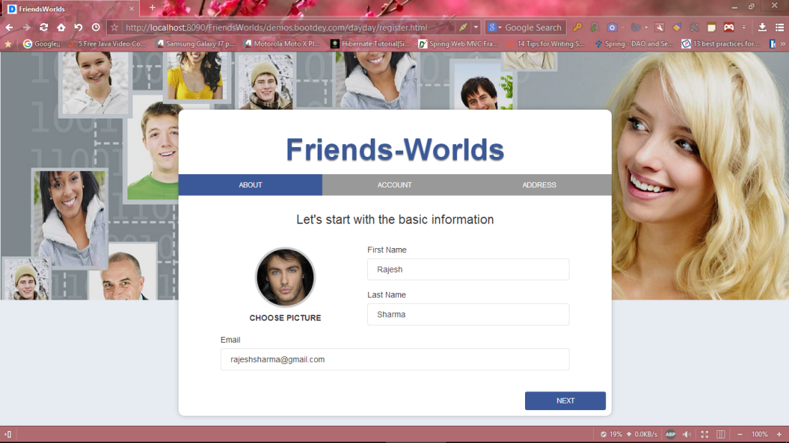

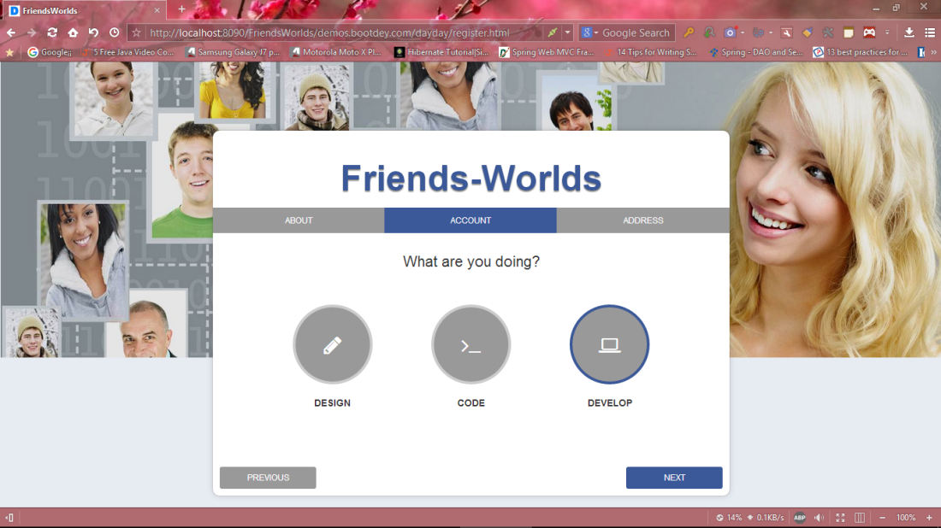

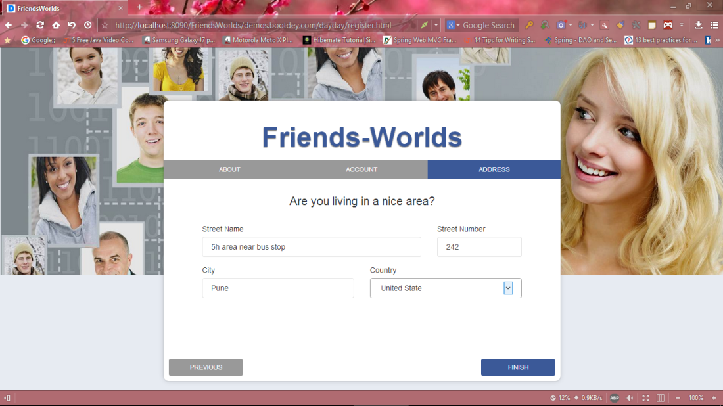

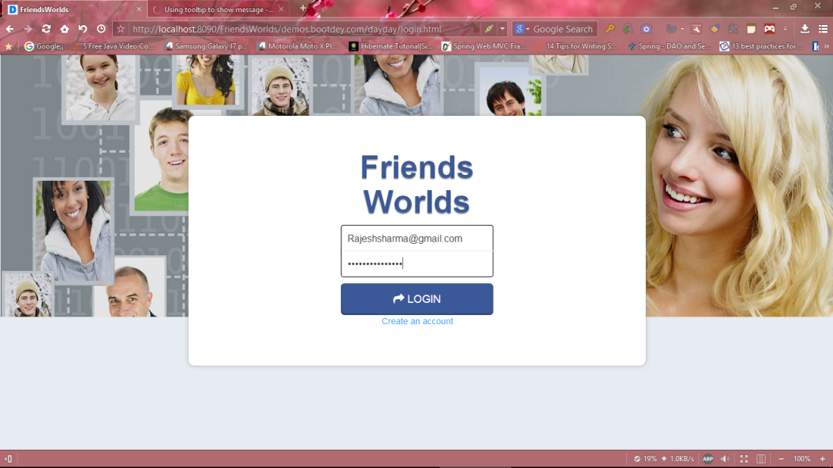

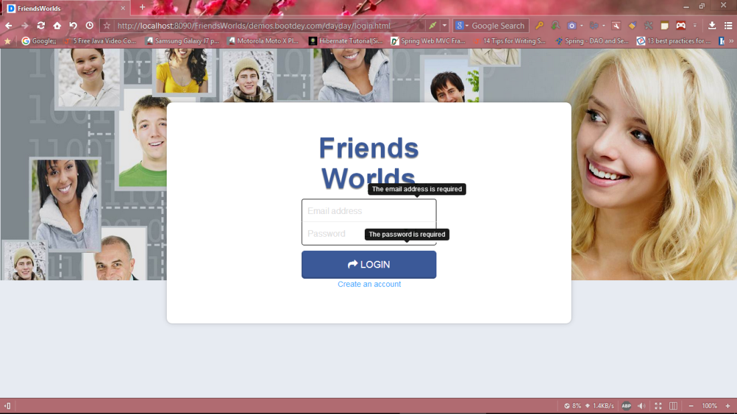

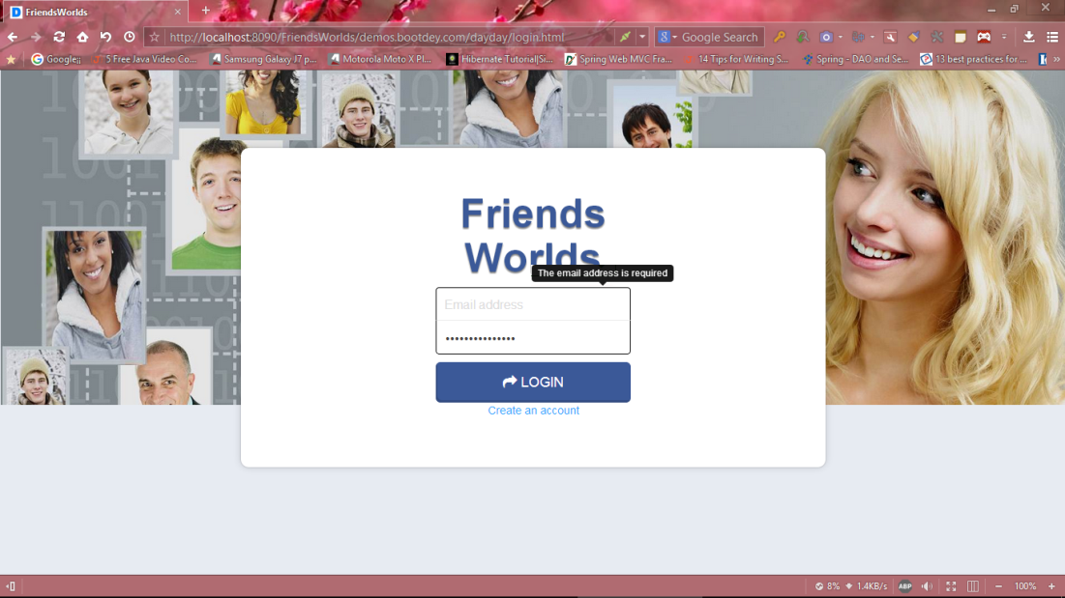

After login blank timeline

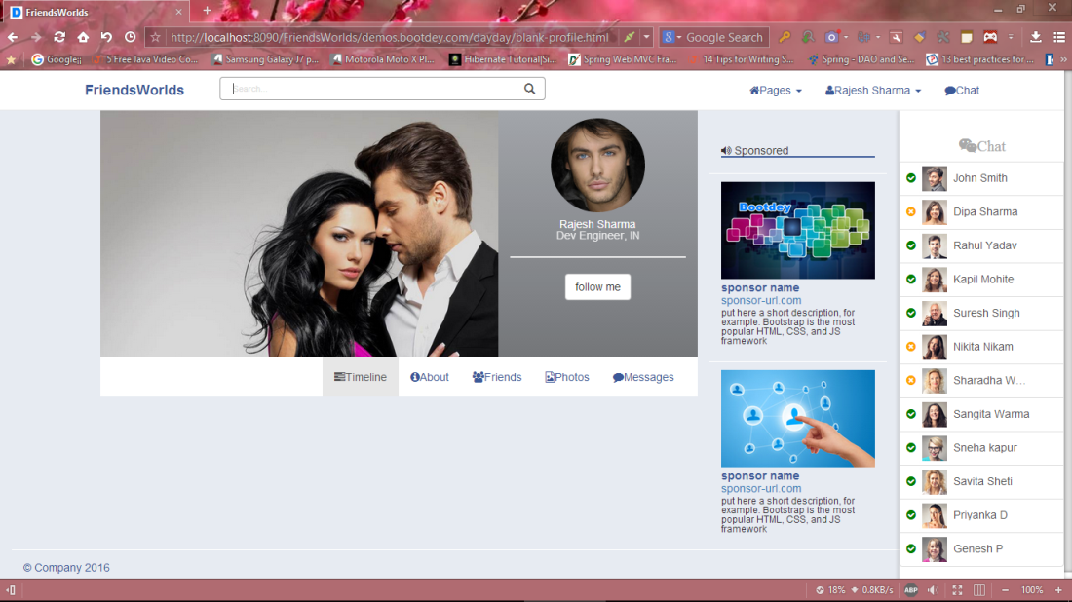

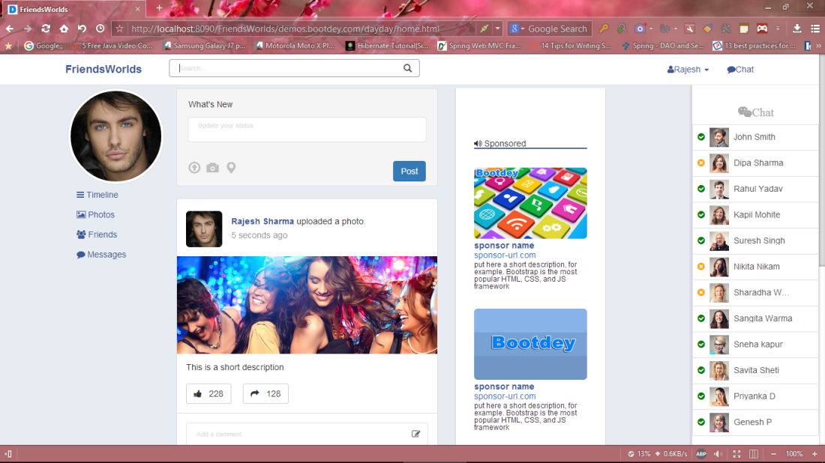

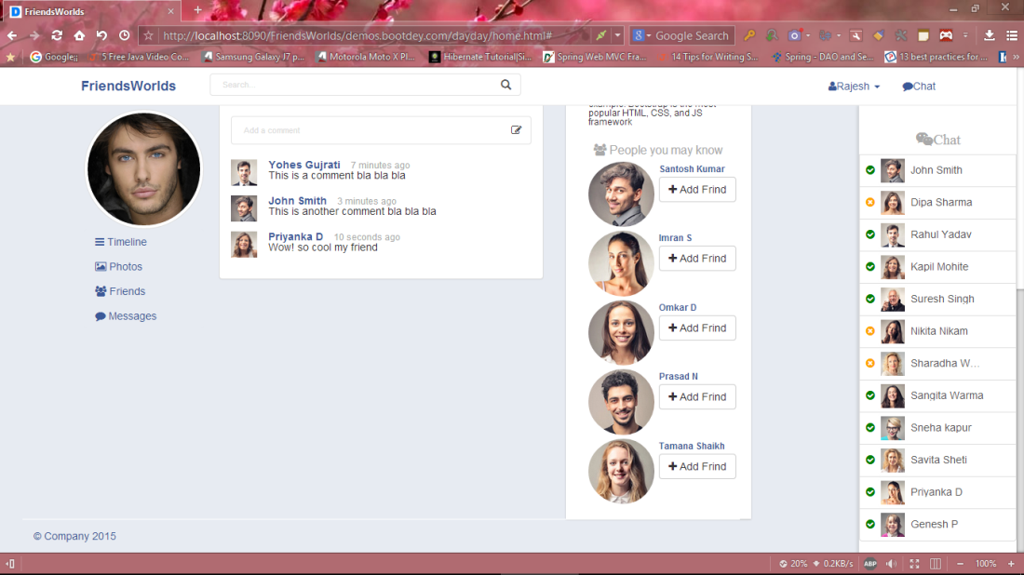

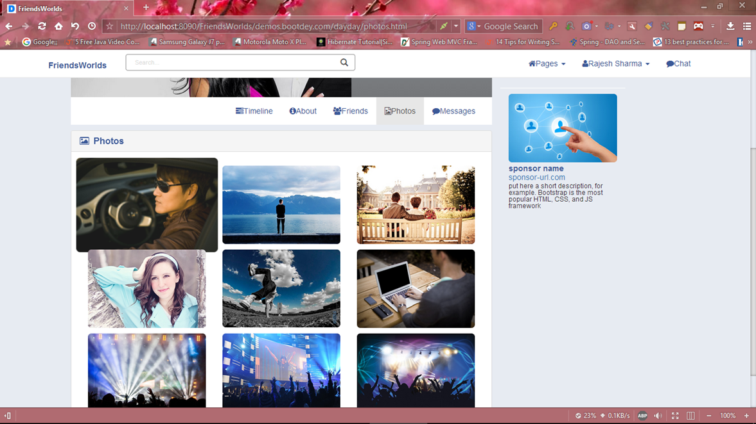

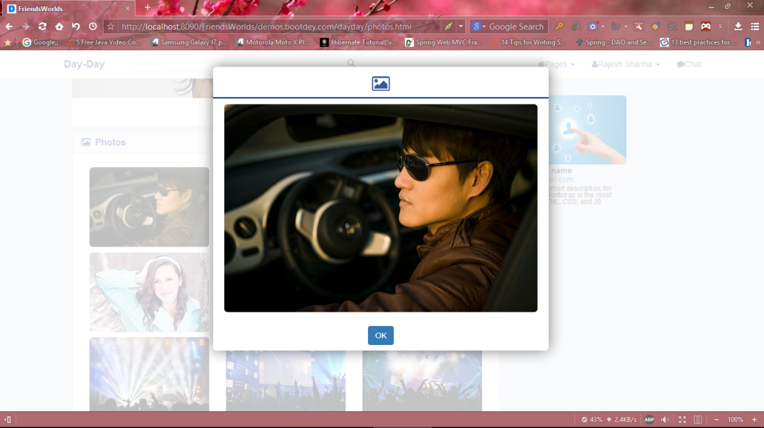

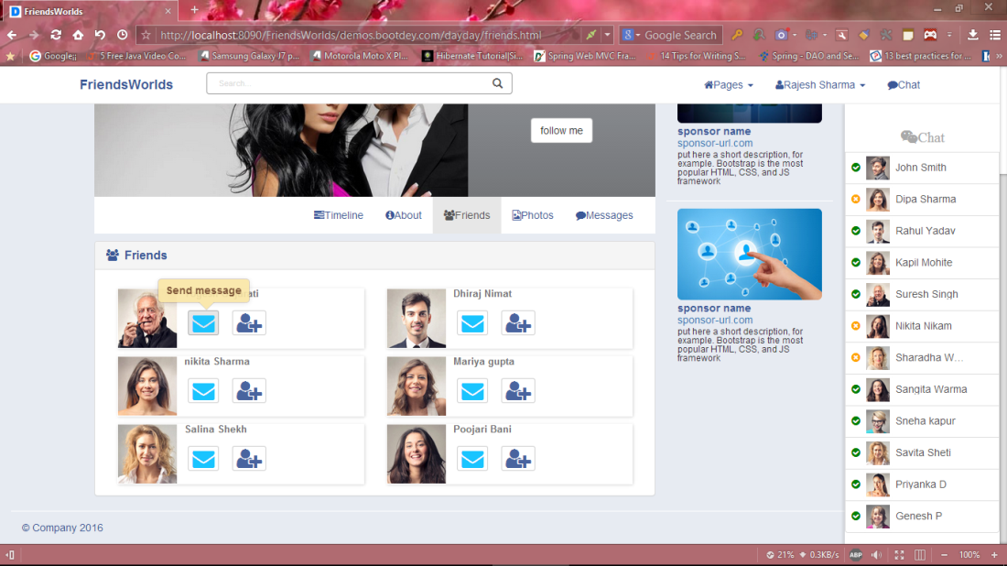

Post

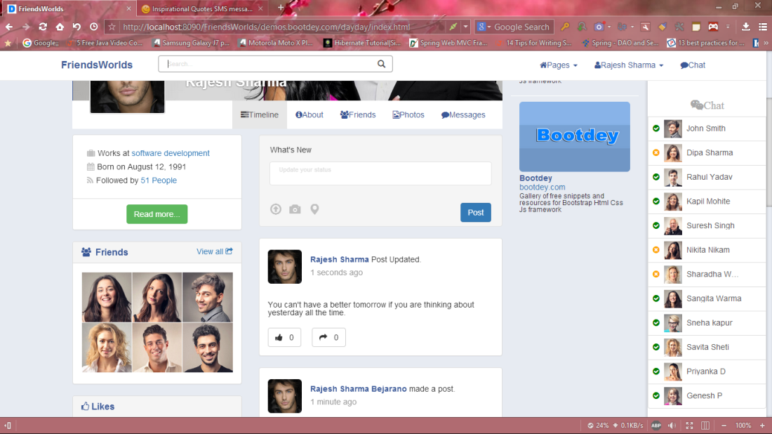

Chating

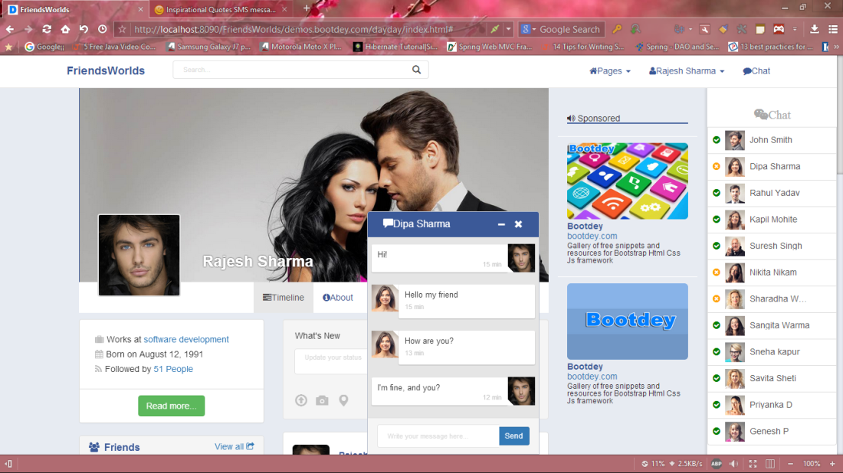

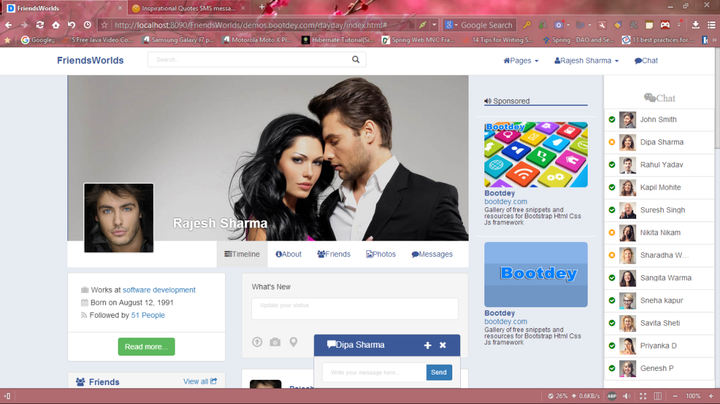

Hide chat

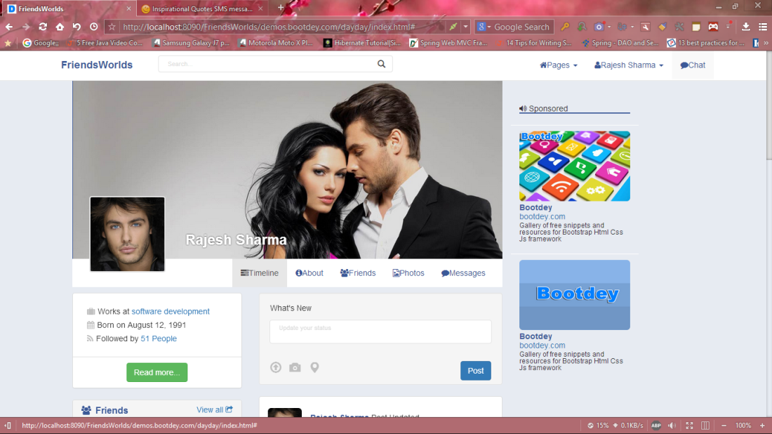

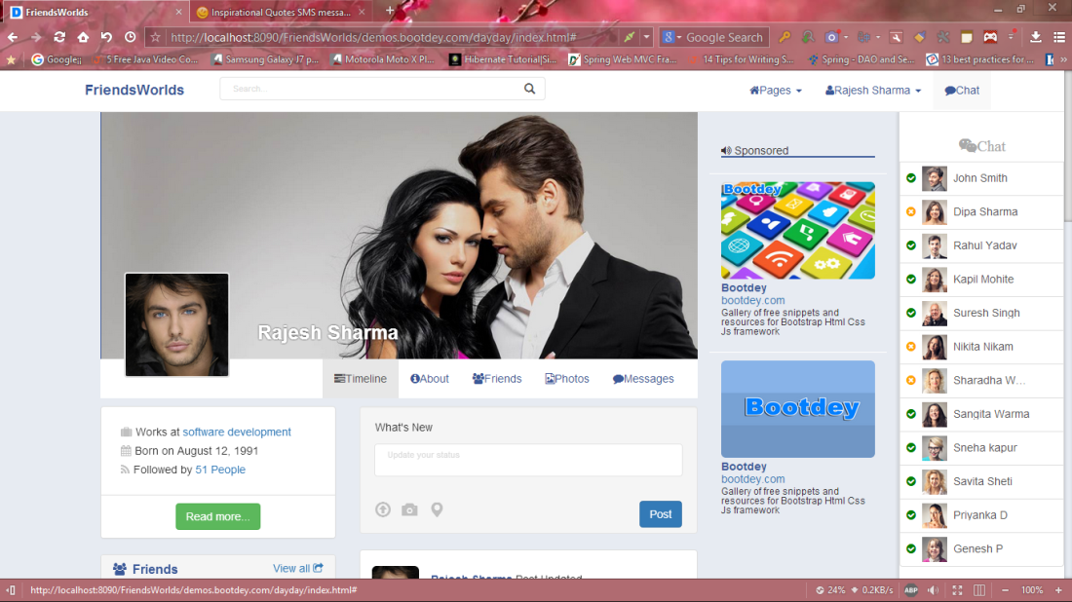

About us

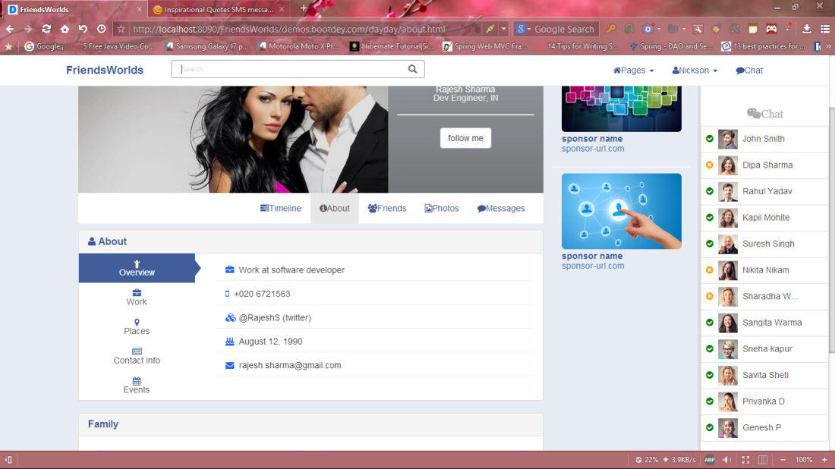

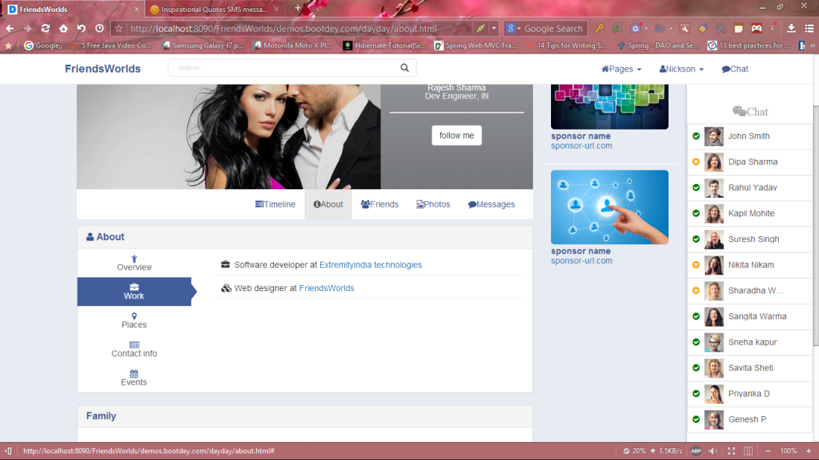

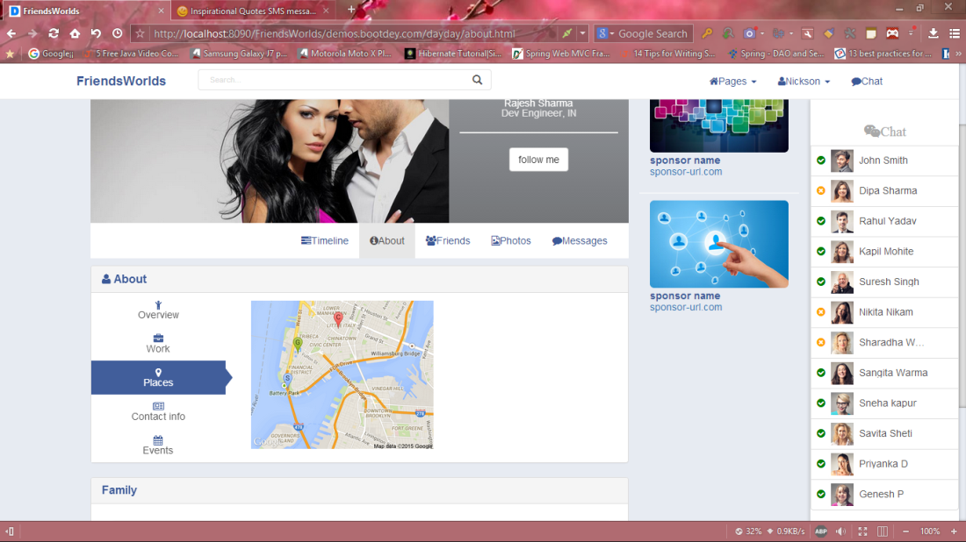

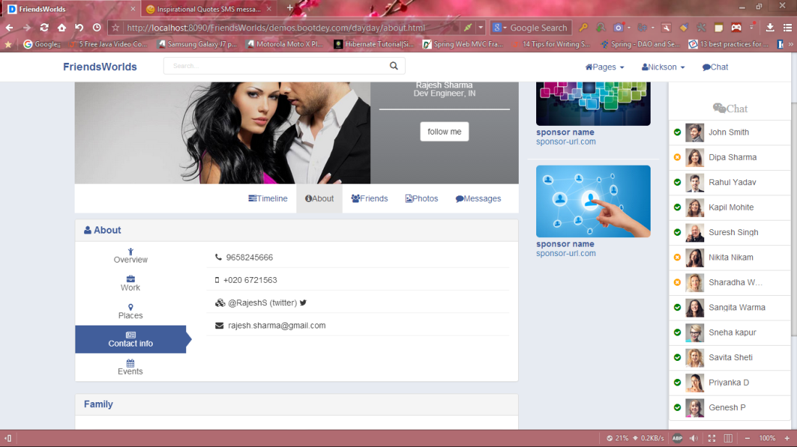

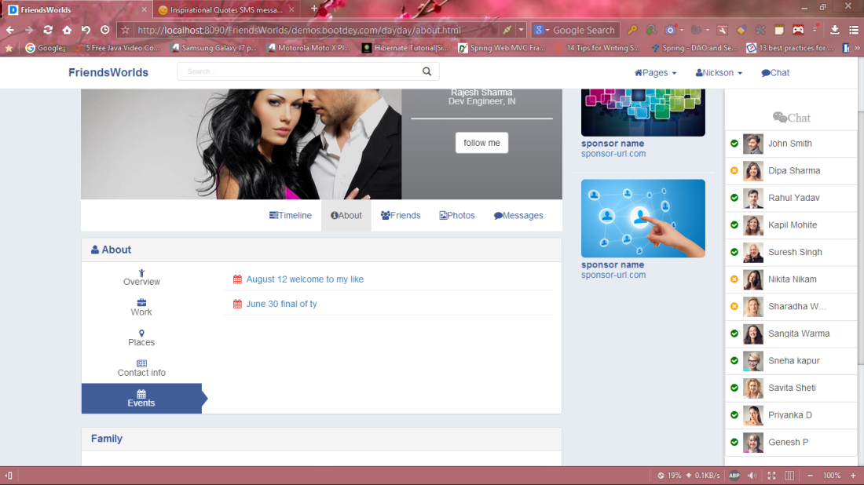

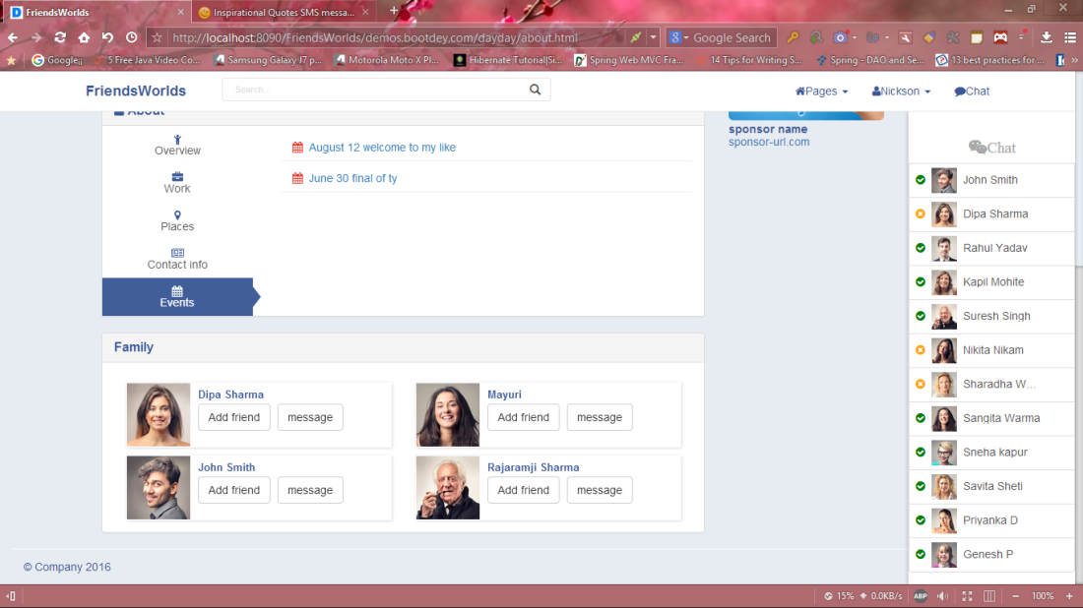

Chating floor

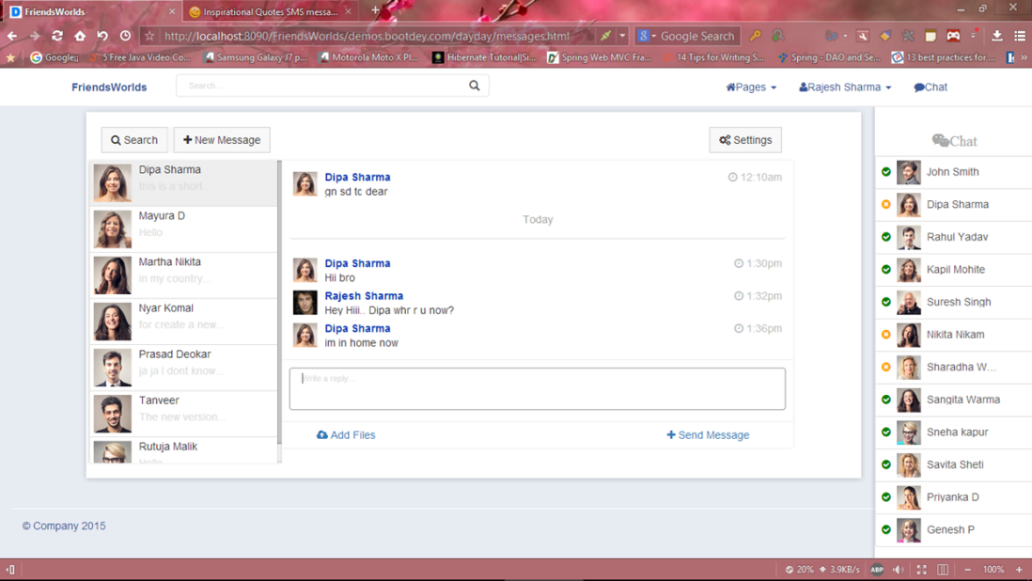

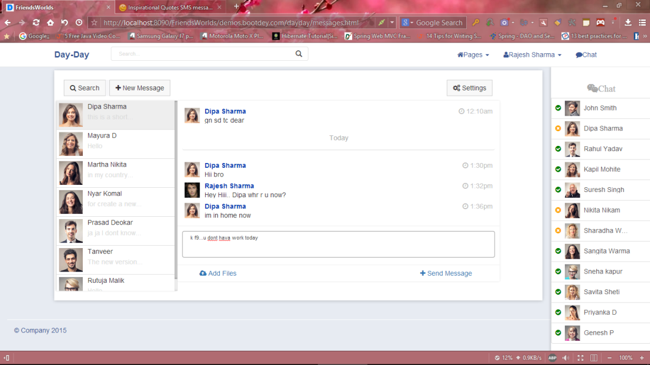

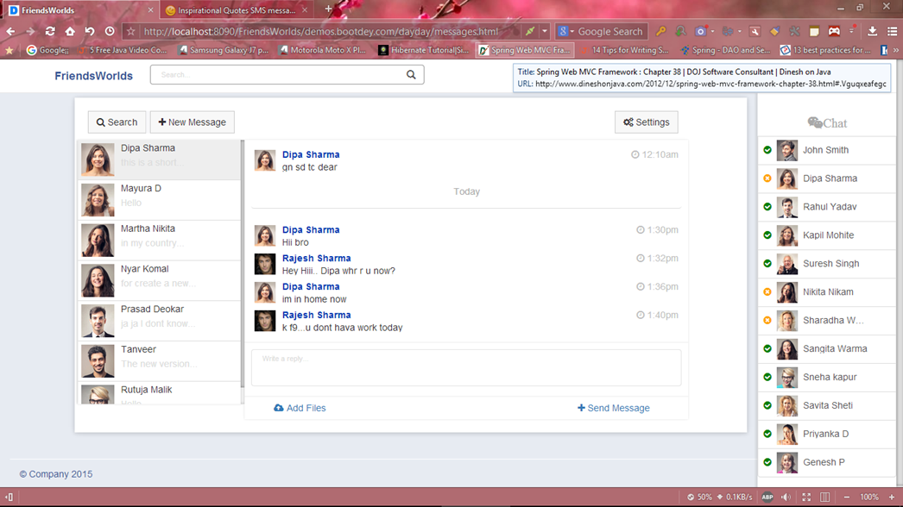

**3.11** **Table Specification**

**U**ser

|  |  |  |  |
| --- | --- | --- | --- |
| Field Name | Data type | Constraints | Description |
| User_id | String | Primary key | Unique user key |
| User_name | String | Not Null | User name |
| password | String | Not Null | User password |

**Registration**

|  |  |  |  |
| --- | --- | --- | --- |
| Field Name | Data type | Constraints | Description |
| new_user | String | Not Null | User name |
| User_id | String | Primary Key | User primary key |
| password | String | Not Null | User password |

**Profile**

|  |  |  |  |
| --- | --- | --- | --- |
| Field Name | Data Type | Constraints | Description |
| First_name | String | Not Null | User first name |
| Last_name | String | Not Null | User last name |
| Dob | String | Not Null | User date of birth |
| User_id | String | Foreign key | User id |

**Chatinfo**

|  |  |  |  |
| --- | --- | --- | --- |
| Field Name | Data type | Constraints | Description |
| Chat_id | String | Primary Key | Chat id |
| U1_id | String | Foreign key | User primary key |
| U2_id | String | Foreign key | User primary key |

**Message**

|  |  |  |  |
| --- | --- | --- | --- |
| Field Name | Data type | Constraints | Description |
| Recipient | String | Not Null | Receivers user name |
| Subject | String | Not Null | Subject of message |
| User_id | String | Foreign key | User unique key |
| Message | string | Not Null | Message |

**Chatlist**

|  |  |  |  |
| --- | --- | --- | --- |
| Field Type | Data Type | Constraints | Description |
| User_name | String | Not Null | Online user’s name list |

**Admin**

|  |  |  |  |
| --- | --- | --- | --- |
| Field Type | Data type | Constraints | Description |
| admin_id | String | Primary key | Unique for admin |
| Password | String | Not Null | Admin password |

**Announcement**

|  |  |  |  |
| --- | --- | --- | --- |
| Field Type | Data Type | Constraints | Description |
| admin_id | String | Foreign key | Unique id for admin |
| Announcement_message | string | Not Null | Admin post the announcement related to competition or event |

**Comment**

|  |  |  |  |
| --- | --- | --- | --- |
| Field Type | Data Type | Constraints | Description |
| User_id | String | Foreign key | Unique id for user |
| Comment_content | String | Not Null | User’s comment |

**Like**

|  |  |  |  |
| --- | --- | --- | --- |
| Field Type | Data Type | Constraints | Description |
| User_id | String | Foreign key | Unique id for user |
| Like_no | Integer | Not Null | User’s like number |

**3.12 Test Procedure and Implementation**

Any data item will have certain constraints like, the type of the data, length of the data, unique data. And when getting these data from the user appropriate tests should be done to ensure that the data item confirm to the constraints.

This is called “validation of the data”, only after the validation, it can be said to be data. There are number of tests in the application to ensure these constraints which are listed below:

**Type Checking**

Any data item should be of some type. User should be prevented from entering other type of data.

**Length Checking**

The length of the data items should be checked as most of the data items have some valid length as one of their constraints.

**Control Design**

The application being a GUI application should be provide the user to enter the data in the order they prefer to enter, except to certain key data items. Even though existence tests have to be done on these.

**Testing**

Testing presents an interacting anomaly for the software engineer. The engineer creates a series of test cases that are intended to ‘demolish’ the software that has been built. In fact, testing is the one step in the software engineering process that could be viewed as destructive rather than constructive.

All testing activates were carried out keeping in mind the following things:

* All test should be traceable to customer requirement.
* Test should be planed before testing commences.
* Initially testing should begin in small and gradually it should grow in shape.

**White Box Testing**

* This approach was used to test the logic or code written and also to check that the system is functioning according to the specifications.
* Using this approach, every statement of the project was executed and tested for bugs.
* It’s useful in finding logical errors in the code such as variables that were not declared, wrong execution of different types of loops and incorrect conditions.

**Black Box Testing**

* The end users were not concerned with the code of the system but concerned with inputs and outputs that the system accepted and generated.
* It was useful in finding out interface errors. Boundary value of variables and conditions check.

**Test Model**

**Unit Testing**

Unit Testing is done software prototype to determine that individual program modules perform to specification. In unit testing each module is tested alone in an attempt to discover any errors in its code. This involves the design of the test cases that validate that the internal program logic is functioning properly, and that program inputs produce valid outputs. All decision branches & internal code flow should be validated. Unit testing involves the use of debugging technology & testing techniques at an application component level and is typically the responsibility of the developers, not the QA staff.

**Integration Testing**

Integration testing is a systematic technique for constructing the program structure whole at the same time conducting tests to uncover errors associated interfacing, the objective is to take unit tested modules & build a program structure that has been dictated by design.

**Validation Testing**

The function or performance characteristics conform to specification & are accepted. A derivation from the specification is uncovered & a deficiency list is created.

**Output Testing**

The output testing involves the checking of output from the software from various dummy inputs. If the output provided is as expected, then the s/w can be considered to be given the desired output for given inputs.

**Test Model**

**User Acceptance Testing**

The user acceptance testing can be done in two places viz., Alpha testing and Beta testing. A customer does the alpha testing at the developer’s side. The s/w is used in a natural setting with developer & recording errors & usage problems.

Real world simulation is done so that the customer can test the system. There simulation help the developers & the customers to find any real time bug disrupting the normal functioning of the system

**Implementation**

It is considered with those tasks leading immediately to a fully operational system. Its involves programmers, users, operation management, but its planning & timing is a prime function of system analysis. It includes the final testing of the complete system to user satisfaction & supervision of the initial operation of the new system.

**TEST CASES AND TEST REPORTS**

**Login:**

|  |  |  |  |  |  |  |
| --- | --- | --- | --- | --- | --- | --- |
| **Test**  **Case**  **No** | **Objective** | **Condition** | **Steps /**  **Input** | **Expected**  **Result** | **Actual**  **Result** | **Remark** |
| 1 | Logged  into system | Valid  Login | Enter valid username and password. Click on login | User successfully logs into the site & home page should be displayed. | User logged in & Home Page displayed. | - |
| 2 | Validation check for username | Invalid username | Enter invalid username Enter valid password. Click on login. | Error message window should be display with proper error message. “Invalid username”. | Error message invalid username or password. | - |
| 3 | Validation check for password | Invalid password. | Enter valid Username. Enter invalid password. Click on login. | Error message window should be displayed with proper error message “invalid password” | Error message  “Invalid username or password”. | - |
| 4 | Validation check of both username and password | Invalid username and password | Enter invalid username. Enter invalid password. Click on login. | Error message window should be displayed with proper error message  “invalid username or password” | Error message  “Invalid username and password”. | - |

**Registration:**

|  |  |  |  |  |  |  |
| --- | --- | --- | --- | --- | --- | --- |
| **Test**  **Case**  **No** | **Objective** | **Condition** | **Steps /**  **Input** | **Expected**  **Result** | **Actual**  **Result** | **Remark** |
| 1 | Validation check for any blank fields in the form. | Validation check of customer information | Data not entered in the form. Click next. It will show the error messages. | Error messages will be shown as  “Please enter all the data” in the form | Error  Message  Displayed. | - |
| 2 | Validation check for customer Name. | Customer Name not entered correctly. Other fields entered correctly. | If wrong customer name is entered then it will show the error | Error message as  “Please enter proper Name” | Shows  error message | - |
| 3. | Validation for Email id | Email id not entered correctly and  All other fields are correct. | If wrong email id is entered then it will show the error | Error message as  “Please enter Correct email id” | Shows  error message |  |
| 4. | Validation Check for Fax no. | Fax no. not entered correctly | If wrong fax no. is entered then it will show the error message | Error message as “Please enter correct Fax no.” | Shows error message |  |
| 5. | Validation Check for username | Username not entered correctly | It will show error message | Error message as “Please enter correct Username” | Shows Error Message |  |
| 6. | Validation Check for Password | Password not entered  Correctly | If wrong password is entered It will show error message | Error message as “Please enter Correct Password” | Shows Error message |  |
| 7. | Validation Check for Contact No. | Contact no. not entered correctly | If wrong contact no. is entered It will show error message | Error message as “Please enter Correct Contact no.” | Shows error message |  |
| 8. | Validation Check for name of Contact Person | Contact Person Name not entered correctly | If wrong name is entered it will show error message | Error message as “Please enter Correct Name Contact Person” | Shows Error Message |  |
| 5. | Validation Check for username | Username not entered correctly | It will show error message | Error message as “Please enter correct Username” | Shows Error Message |  |

**Chapter 4**

**USER MANUAL**

4.**1 User Manual**

* **Chatting**

One of the advantages of having friends is the ability to have live communications with them via chat. When a friend is online, he/she will appear in the chat tab as an available friend to chat with. To start a chat session, simply click on the name of the friend which will begin a new chat session. The little bar at the bottom will change from chat disabled to chatting with friend name as seen in the ﬁgure below. Also, the friend receiving the chat will get a notiﬁcation that a new chat session has started. Then the two friends can chat with each other until one or both log out.

The chat feature is a little more complex than others as it requires a combination of JavaScript and JQuery to work. When a user clicks on a friend name to begin a chat, a chat request is sent to the database. On every page there is a JQuery function that queries the server for any new chat requests once a second. It needs to be JQuery, so the client can request for the server to run a check and return any relevant information. If it was pure PHP, the page would never load completely, because the page cannot ﬁnish loading until the server is done all preprocessing. The JavaScript portion of JQuery allows the client to ask the server to do more processing after the page has been loaded.[3] If there is a new chat request, a pop under is generated, notifying the receiver of the new chat that is starting or a new pending chat if the user is in another chat. When a user send a message, another JQuery function is called, to alert the server that it needs to update the chat session with a new message. At the same time, another JQuery function is running to ask the server once a second if the chat session has been updated. Overall, it is a lot of the client asking the server to send over any changes that exist.

* **Messaging**

Unlike with chatting, users can send a message to any other user. For user A to send a message to user B, he/she simply goes to the message center tab and clicks compose message. He then ﬁlls out the form as shown in the ﬁgure below with the email of the recipient, the message title, and the message content. The new message will then be in User B’s inbox in the message center.

Messaging is implemented by storing a record of the message in the server. First a message object is constructed that takes in the to and from accounts, the message body, and the date it was sent. The message body is retrieved from a user submitted form, the from account is retrieved from the user session, and the receiver account is retrieved from the recipient email address. The receiver account is validated, to ensure the sender didn’t try to send a message to a non-existent receiver. Finally, the new message is stored in the server. Retrieving messages sent to the user is a simple method of querying the server for any messages that have been sent to the user, and this is done by checking the receiver id of each message against the account id of the user. Any matches are returned to the inbox of the user as shown in the ﬁgure below.

* **Events**

In addition to messaging your friends, social networking sites are a great place to alert your friends of important upcoming events. For example, if a user is throwing a birthday party, he/she could create an event an invite friends he/she wants to attend or simply make it a public for anyone. The process of creating an event is as simple as ﬁlling out a form which looks like this.

After ﬁlling out the form, the user will be brought to the standard conﬁrmation page. He/she can then view the new event by clicking on the Events tab and clicking on the new event. If the user wishes to edit some information about the event, he/she can click on the edit link next to the event where a similar form to creating an event will be displayed with all the ﬁelds populated with the current event information.

Storing the event is a fairly straightforward process. Once the form data is submitted, a new Event object is created storing the Account that created the event as well as all the information sent along with the form. That new event is then sent to the server, which creates a database query and stores the ﬁelds of the event object into equivalent ﬁelds of the event database table. Retrieving events is also a fairly straightforward process. A MySQL query is called to pull the contents of the event into an array, and that array is used to instantiate a new working copy of the event in an Event object.

* **Media Uploading**

As people use their social networking account, they will want to be able to upload funny or interesting images, video, music, etc., to share with their friends. The media upload section will be located at the media tab, where users are able to specify a ﬁle to upload as well as provide a short description of the ﬁle to be uploaded. In order to prevent users from uploading potentially malicious ﬁles such as executables, only certain ﬁle extensions are supported. These allowed extensions cover popular image extensions such as png, jpg, gif, and bitmap, video extensions wmv and avi, audio extensions mp3, wma, and wav, and some document ﬁles including txt, rtf, doc, and pdf.

The inner workings of this uploading process are surprisingly simple, since the HTTP server takes care of requesting the ﬁle from the client automatically. After the user clicks upload, the ﬁle is sent to the server and stored in a temporary location. Through PHP all information about these temporary ﬁles can be accessed through the $ FILES variable. The temporary location is stored in that variable and can be used to pull the ﬁle name and ﬁle extension.[1] That extension is then checked against an array of allowed extensions. If the extension is in the list, the ﬁle is then moved to a permanent location in the media folder under a subfolder for the user’s account. If the extension is not on the list, it is left in the temporary folder where it will be automatically deleted by the server once the php script completes.

**2.3 Non-Functional Specification**

* Secure access of confidential data by user name and password. This application is secure for every kind of its users, because if any user logout from any session then nobody will be able to access his profile without knowing his confidential password.
* 24 X 7 availability
* Better component design to get better performance at peak time.
* The database used here is robust, reliable & fast. So users will have to wait for the output very short time.
* This application can be accessed from any type of platform.
* There is no case of redundancy in the database so it will not take extra memory space.
* Username & password are sent to the users via email after registration.
* Password recovery system is also provided in case of forgetting the password.

**Chapter 5**

**DRAWBACKS AND LIMITATIONS**

**Drawbacks and Limitation**

* Although we have tried our level best to make this system effective and efficient, there are some limitations, which we have realized. The system has following limitations and constraints.
* System is not totally automated some manual processing is required.
* Limited number of scenarios covered.
* System requires an internet connection.
* User should have basic knowledge of how to use internet.

**Chapter 6**

**PROPOSED ENHANCEMENT**

**Proposed Enhancements**

* + We are trying to make system more easy to use.
  + We are trying to make system as small as it would be accessed on mobile also.
  + We are trying to make available the Service information in more details.

**Chapter 7**

**CONCLUSION**

**Conclusion**

During development of this system we learned new technologies, which would serve us in future. We have tried our level best to develop a system according to user requirement.

Although during development we did come across many problems both technical and conceptual. But we solved all those during development period. Also we can’t ignore the drawbacks and limitations of our system and in future we will make the enhancement on the system.

Altogether it was a great experience, and we have learned a lot during system development. Working on this project we got exposed to realistic approach of designing and could learn various strategies of hedging risks and also improvise our development skills. During the process of development we have learn cutting edge technologies like .Net specially involving WPF.

**User Friendly:**

As the system performs validation in each screen where input is received from the user and it also provides the user with appropriate messages when any mistake is committed there is no need for the user to be extra cautious while working on the system.

**Easy to Maintain:**

All the standard conventions defined by the software engineering, the programming conventions defined by Java etc. are followed strictly while development so the system is easy maintain.

**Easy to Modify:**

The system is meant to be adoptive in changing working environments as it is developed using Java. At the end, this web based system developed on the Java conventions using Ajax, Hibernate and Struts. Helped me to learn a lot about the web application development. I learned various tools that can be used for the development of such kind of projects. And I also learned how the working in the software enterprise is carried out

**Chapter 8**

**BIBLIOGRAPHY**

**Bibliography**

**Books:-**

For the reference purpose, following books were referred:

* **The Complete References Java Seventh Edition-**By Herbert Schildt
* **Head First-** By Bert Bates and Kathy Sierra
* **SCJP-** By Kathy Sierra

**Web References:-**

* [www.google.com](http://www.google.com)
* [www.wikipedia.com](http://www.wikipedia.com)
* www.javatpoint.com
* www.docs.oracle.com
* [www.w3school.com](http://www.w3school.com/)
* www.mkyong.com